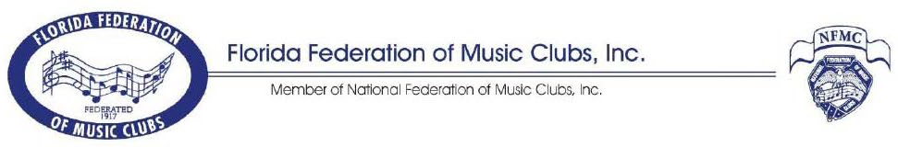FFMC Application Form DEADLINE:December 15, 2023

FFMC ESSAY CONTEST
2024 Theme: "Music...Yours, Mine, and Ours"

(Must be 500 words or less, typed.)

Entrant: Grade in School: ___7 ___8 ___9 ___10 ___11 ___12

Street Address: City, ST Zip

Telephone: Email:

FFMC Membership required - Indicate: member of an active FFMC Junior Club or junior individual member.

Name of FFMC Junior Club:

I hereby certify that I am eligible to enter this contest according to the rules and will comply with all conditions outlined. Refer to FFMC website for additional details: https://ffmc-music.org/essay.

Signature of Entrant: Date:

Signature of Parent: Date:

Teacher's Name:

Street Address: City, ST Zip:

Teacher’s Email: Telephone:

FEE: Amount Enclosed: Check # Date: _____________________

Please mail your FFMC essay along with $5 entry fee, payable to FFMC, Inc. and send with this signed entry form to:

Amy Duncan, FFMC Essay Chair 16559 Arrowhead Trail Clermont, FL 34711
Deadline to submit FFMC essay: December 15, 2023. If needed, include $13 junior individual dues to satisfy FFMC membership requirement. Questions? Amy Duncan: ycmband@gmail.com

* * * * * * * * * * * * * * * * * * * * * * * * * * * * * * * * * * * * * * * * * * * * * * * * *

Membership is NOT required for the National Federation of Music Clubs National Music Week Essay competition. For further information, refer to Form AR 13-2 “National Music Week Essay Rules” available for download from the NFMC website at https://www.nfmc-music.org

Upload NMW essay entry materials online by January 10 via the submission portal https://forms.nfmc-music.org.

